**Lab 3: Using EF Core CLI to Create and Apply Migrations**

**Step 1: Install EF Core CLI**

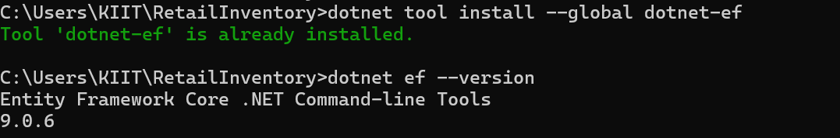

**Step 2: Create Initial Migration**

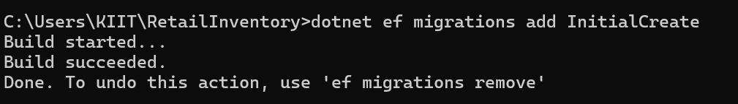

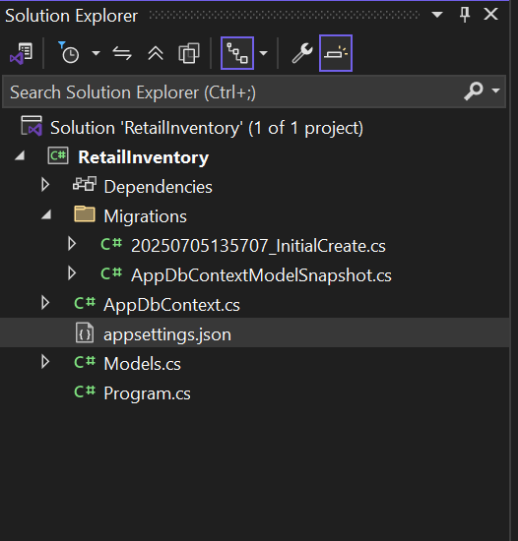

**Step 3: Apply the Migration to Create the Database**

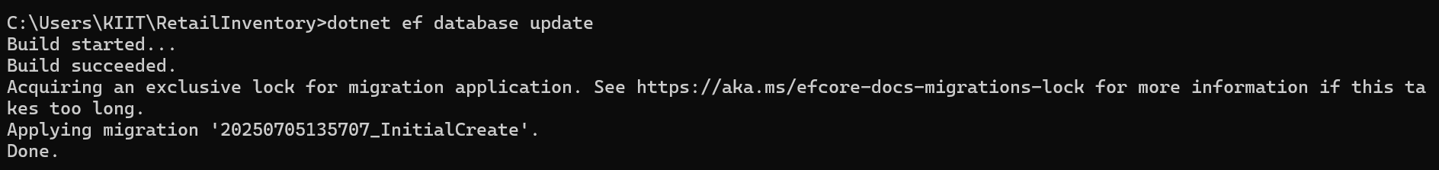

**Step 4: Verify in SQL Server**

